**Summary of video tutorials 16, 17, 18, 19 for Blender 2.80.**

Tutorial series: <https://www.blender.org/support/tutorials/>

Video 16: <https://www.youtube.com/watch?v=RRilLLyyn1Y&list=PLa1F2ddGya_-UvuAqHAksYnB0qL9yWDO6&index=17&t=0s>

Video 17: <https://www.youtube.com/watch?v=0zrd37k2tJM&list=PLa1F2ddGya_-UvuAqHAksYnB0qL9yWDO6&index=18&t=0s>

Video 18: <https://www.youtube.com/watch?v=TMPjKVgTfYs&list=PLa1F2ddGya_-UvuAqHAksYnB0qL9yWDO6&index=18>

Video 19: <https://www.youtube.com/watch?v=Y7M-B6xnaEM&list=PLa1F2ddGya_-UvuAqHAksYnB0qL9yWDO6&index=19>

**1. Summary of video 16: Introduction to Shading – Texturing using images.**

Open a new blender workspace, save the newly created space to your working folder. Copy the image file *pattern.png* to the same folder. Switch to the shading tab. Left click (in the top left hand corner) of the bottom left panel and select UV editor rather than Image editor. If you hover your mouse over the panel selection, blender will return your current window option, see step 9 (Image editor becomes UV editor). Find the pattern file using the file finder in the top left panel and drag the *pattern.png* file into the shader editor window (middle bottom), it should appear as a new panel. Alternatively, you can select Add -Texture -Image Texture and then open the file using the dialogue box. Wire the colour out from the panel to the “Principled BSDF” shader panel. Press Z in 3D viewport and make sure you have selected “material preview” or “rendered”. The cube should now appear textured (as if wallpapered by the pattern). Change the mode of the 3D view port to Edit Mode (rather than Object mode). Press “A” to select all vertices in the 3D viewport and you should see the corresponding points mapped in the UV editor. It should now look something like the following. Middle mouse button (wheel) down and then drag to pan. Shift <space> to zoom to a specific window and shift <space> to return to normal layout.

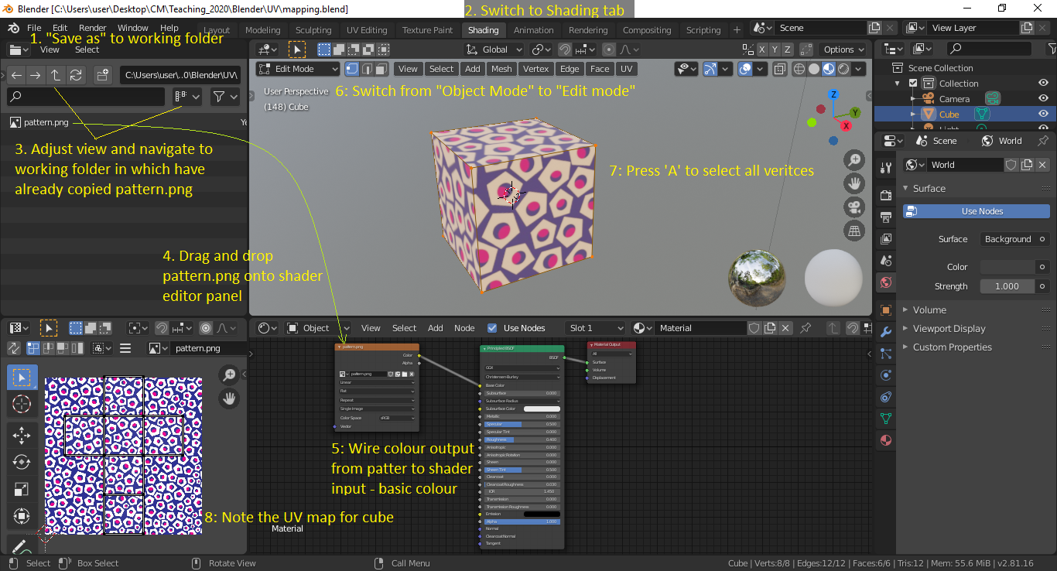

9. Left click – select UV editor not Image editor

Select a single face of the cube in edit mode, then grab each of the vertices in the UV editor and move them to intersect the Maynooth University logo.

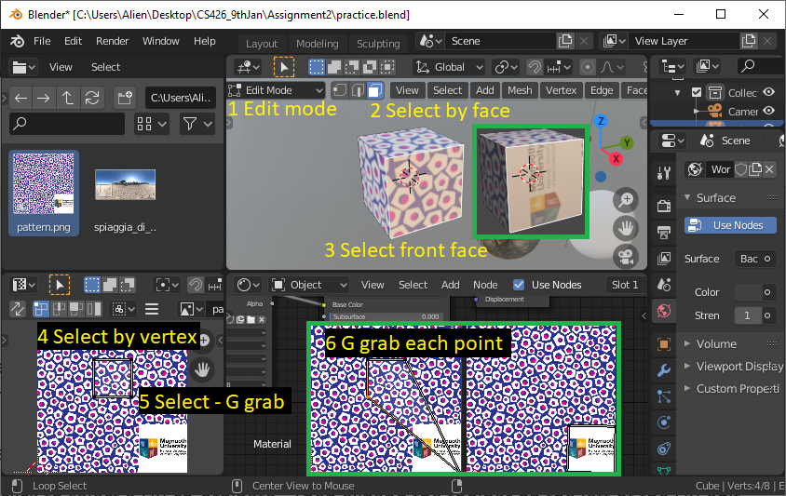

Just pause for a moment and consider all that is going on here.

Step 1: UV – mapping

Each vertex has position defined by three numbers (X, Y, Z). A further two numbers are associated with each vertex (U, V) which represent a position on a 2D image used to render the image on the surface of the object. The image is often used to make the object look as if it is made of a material such as wood or stone.

Step 2: Shading

The final look of the rendered object depends on the interaction of light with the object. The type of surface reflectivity – specular or diffuse, amount of ambient light produced by the object and interaction of the light with the object is modelled by the shader.

The default shader used by blender is “Principled BSDF”. This shader is based on the Disney model known as the “PBR” (physically based render) shader and is compatible with other software such as Pixar’s Renderman® and Unreal Engine®.

Principled BSDF is the default “shader” that Blender 2.8 uses to render an object using “cycles” or “eevee”. On my laptop the Eevee renderer is not working properly so I had to switch to cycles, it is slower but higher quality, only make the change if you have similar problems.

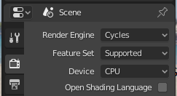

BSDF stands for - Bidirectional scattering distribution function – it models the ambient, diffuse and reflective properties of the surface (and sub-surface) of the object.

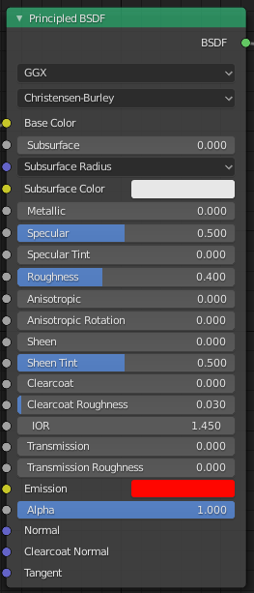

GGX stands for “ground glass unknown”, name of a model that includes glass

Method used to model sub-surface scattering

Base Color Diffuse or metal surface color.

Subsurface Mix between diffuse and subsurface scattering.

Subsurface Radius Average distance that light scatters below the surface.

Subsurface Color Subsurface scattering base color.

Metallic Blends between a non-metallic and metallic material model.

Specular Amount of dielectric specular reflection,water: ior = 1.33, specular = 0.25

Specular Tint Tints the facing specular reflection using the base color.

Roughness Specifies microfacet roughness of the surface

Anisotropic: Amount of anisotropy for specular reflection.

Anisotropic Rotation: Sets direction of anisotropy, with 1.0 going full circle.

Sheen Amount of soft velvet like reflection near edges, cloth.

Sheen Tint Mix between white and using base color for sheen reflection.

Clearcoat Extra white specular layer on top of others, car paint.

Clearcoat Roughness: Roughness of clearcoat specular.

IOR Index of refraction for transmission.

Transmission Mix between fully opaque surface 0, glassy 1.

Transmission Roughness used for transmitted light.

Emission Light emission from the surface, like the Emission shader.

Alpha Controls the transparency of the surface, with 1.0 fully opaque.

Normal Controls the normals of the base layers.

Clearcoat Normal Controls the normals of the Clearcoat layer.

Tangent Controls the tangent for the Anisotropic layer.

The BSDF combines the BRDF (bidirectional reflectance distribution function) and BTDF (Bidirectional transmittance distribution function). This modelling of the light as it passes into (and through) an object creates realistic lighting for objects such as skin. The control panel allows a lot of control of the lighting properties of the material, this is summarised below.

Use shift and left-click to select a UV co-ordinate. Then expand the toolbar on the left of the UV edit window. Then move the UV co-ordinates around and note the effect on the rendered image.

At this stage you should notice that “A” selects all items in any window/context and shift/left-click allows you to select a group of items one at time.

Select the front face points of the cube shown in the 3D viewport of the Shading workspace. Do this one at a time or use face selection.

Select these same points in the UV editor window (shift and left-clicking on each UV co-ordinate). Then use the move and rotate tools so that the pattern on the side of the cube is replaced by the Maynooth University logo. Remember you can use ctrl-space to enlarge any editor window to full screen, ctrl-space returns you to the original windows layout, do this when editing UV points in the UV editor window. Go to the Shader edit window (bottom middle) and then Add - Input – Texture coordinate panel and wire the UV output of this panel to the Vector input of the Principled BSDF. This is the default setting anyway but it is probably best to do it. Finally adjust the emission setting of the Principled BSDF so that the cube is emitting its own bright red light. You can go much higher than an emission of 1.0 if you want the object to light the scene. Once you have done this you should have a scene similar to that shown below.

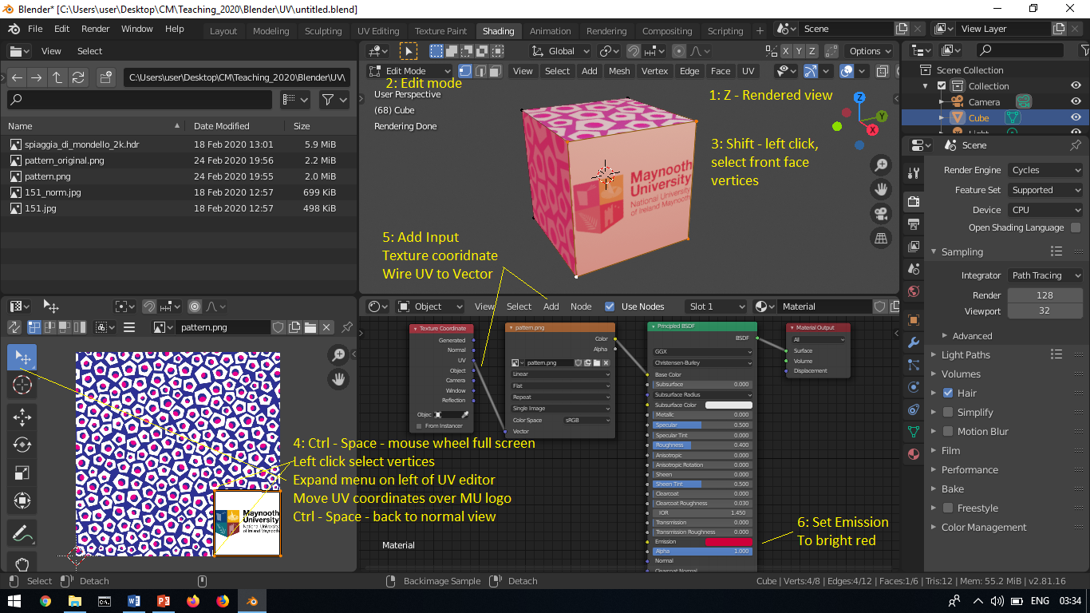

You can break a connect by clicking down and dragging the wire destination connection (not source) and dropping it in a free area.

**Task 1:** Create an image of a cube on which there is rendered a wood or stone finish with your initials written on the front face. Take a screen shot like that shown above showing your rendered scene and the UV editor and Shader editor [3 marks]. Add it to a document. You could add text to the texture or add text as a mesh. Add a light and consider reducing the brightness of the background.

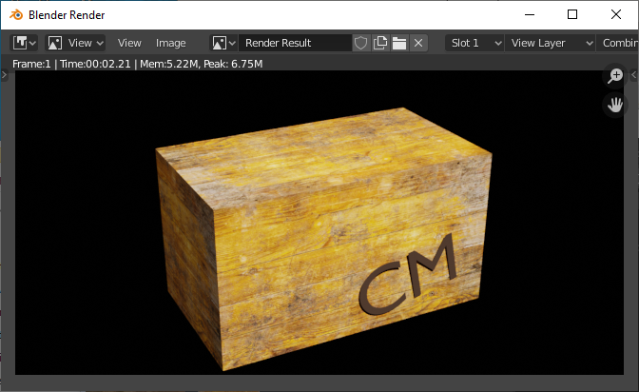

**2. Procedural Texturing – using code to describe the texture (and no images)**

Create new blender workspace, re-open the application and save the space with a new name (perhaps include “pebble” in the name).

To create a suitable background, you can use a HDRI (High Dynamic Range Images). These require special 360 degree cameras capable of recording bright and dark areas in the scene simultaneously. Fortunately, these are available from a number of websites. The HDRI image can form a sky-sphere texture. The image of the light source in a HDRI image also produces light for illumination effects (e.g. the sun appears to shine) without the image itself appearing, which is their main application.

Visit https://hdrihaven.com/ and download a HDRI (High-dynamic-range imaging) file for a beach scene. I choose the following HDRI – 8K resolution (which is also available on Moodle). Place the file in the same folder as your blender workspace file.

https://hdrihaven.com/hdri/?c=outdoor&h=spiaggia_di_mondello

Go to the Shading workspace (click on Shading tab on the top bar). In the Shader edit window (panel in middle near bottom of screen). Change the selection from Object to World. Left click on the back-ground panel to select it then right-click and select delete.

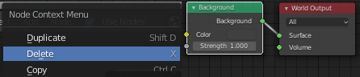

Then select Add – Texture – Environment Texture and wire it to the world output. Left - Click on the Environment Texture file dialogue box and select the HDRI file you wish to use. Aside: you can disconnect a wire by dragging it away from destination e.g. left-click-down on the green dot “surface” and drag it away from the connection, then let go.

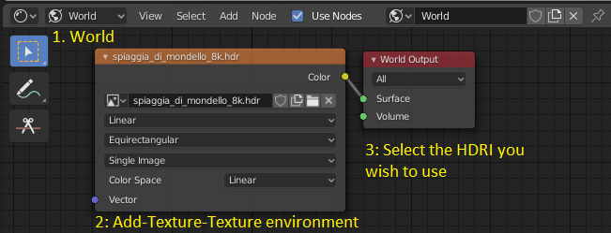

Press Z in 3D Viewport window and select “Rendered view”, wait a few seconds for it to render. Use the view gizmo to look around.

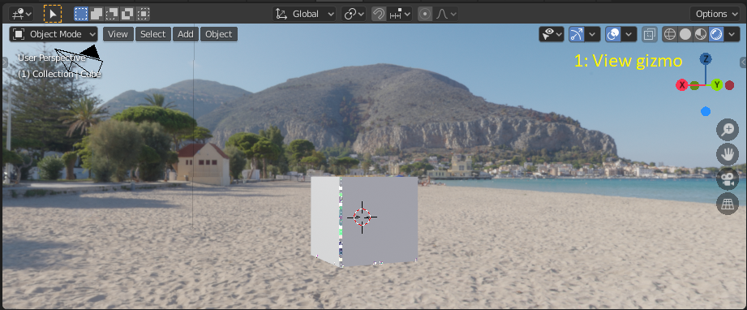

You can change to the Layout tab and then delete the cube, select it by left-click on it and then right click delete or press X. Don’t use “A-select all” to delete the cube as it will delete your camera also.

Use the “Add-Mesh-UV Sphere” tab to add a sphere, select the sphere and apply smoothing.

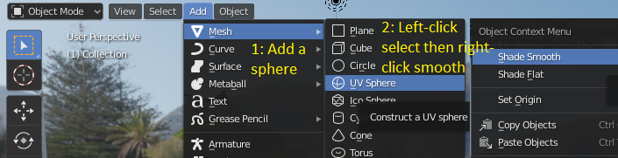

Scale the sphere in the Z axis - pebble, stone or boulder is your choice. Select – S – z and drag mouse.

Change from “Object Mode” to edit mode then select the sphere and rescale the sphere in the Z direction to turn it into an egg shape. You can press the hot key “s” (scale) and then “z” to limit scale changes in the z direction only (up/down). You can use the button on the left if you prefer. You could also rotate the pebble a little.

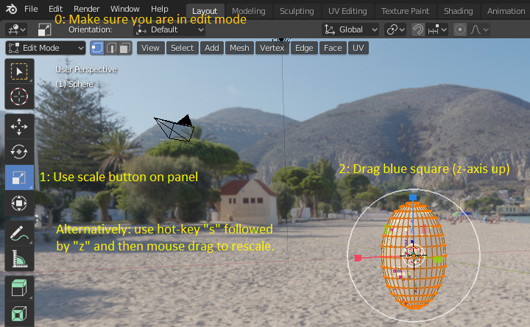

Right Click and select “subdivide” and then adjust fractal value to about <2.5 and apply it once>.

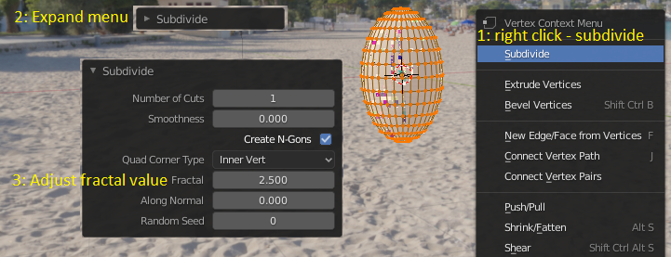

There is a lot more shaping of the pebble the could be done but this makes it have an egg shape with a rough surface.

Return to Object mode and add a plane, make its dimensions 20mx20m.

To add the plane “Add – Mesh – plane – expand menu – set size to 20m.

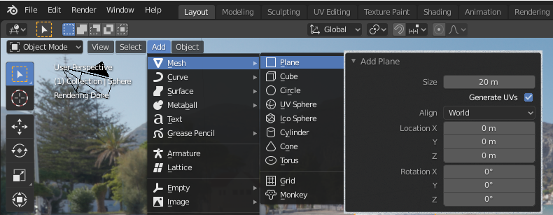

In Object mode select the plane and add “Shadow catcher”, this will only work if you are using Cycles to render. With Eevee you would need to create a new shader see, <https://www.youtube.com/watch?v=DGHW786rpbk>

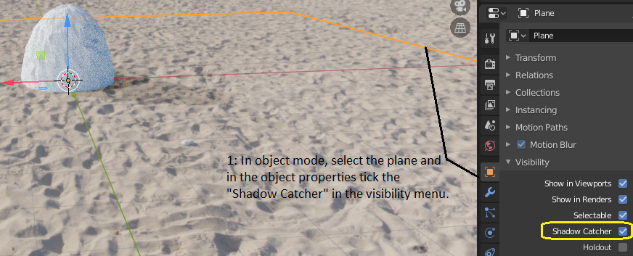

Return to the Shading window and add the following procedural method for shading. In this case we are using code to generate a stone effect rather than using an image to texture the surface. This is becoming the preferred method for creating surface textures. Images are still used for logos, decals etc.

In object mode, select you pebble and then add a “New” material.

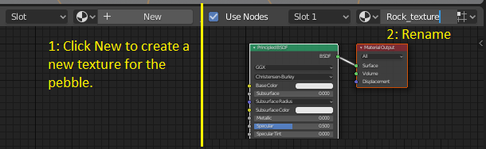

Add the following to the default BSDF based shader to provide a procedural method for texturing.

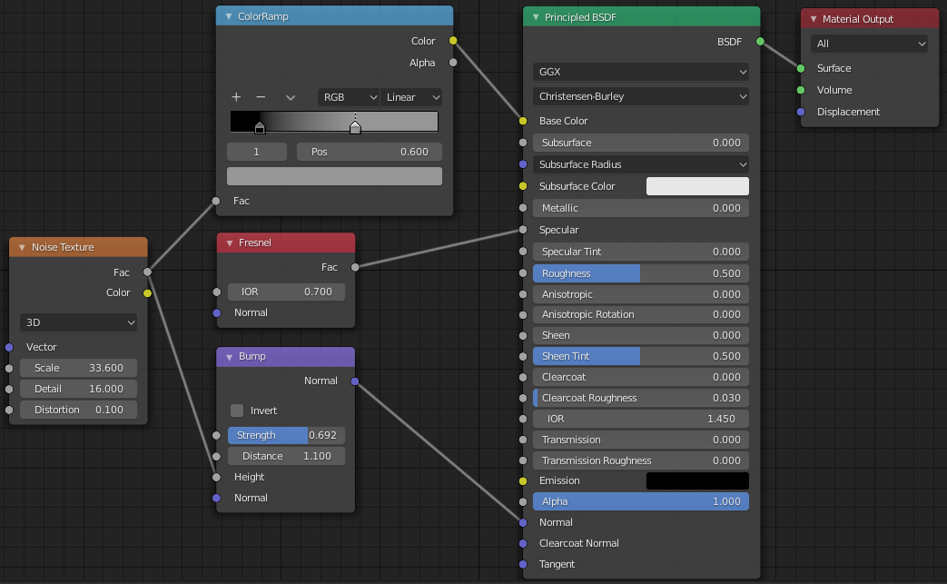

Add texture – noise texture – Scale 33.6, Detail 16, Distortion 0.1,

Add converter –colour ramp – set lower slider to 0.145 and upper slider to 0.60,

Add input Fresnel –set IOR to 0.7,

Add vector bump-strength 0.692, distance 1.1.

The nodes we have added are as follows,

The Noise Texture is used to add procedural Perlin noise texture.

The Color Ramp Node is used for mapping values to colors with the use of a gradient. Finds a colour given a value.

The Fresnel or Dielectric Fresnel node computes how much light is reflected off a layer, where the rest will be refracted through the layer.

The Bump node generates a perturbed normal from a height texture, for bump mapping. The height value will be sampled at the shading point and two nearby points on the surface to determine the local direction of the normal.

You may have noticed that the node connections in the shader have different colours.

grey – grey scale value

yellow – rgba values

purple – vectors (co-ordinates)

green - shader output

Goto your layout tab and you should see a good view of your pebble (or boulder) on the beach with shadow and image HDRI background. If you see two shadows then be sure to delete the default light, select and delete or delete it in the Scene Collection (on top right in Layout view).

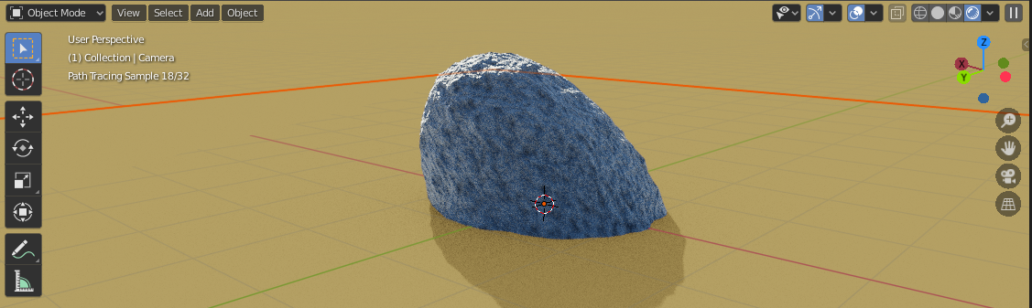

In practice HDRI images are often used for lighting. You can turn their visibility off but leave the effect of their lighting on.

Select Shading and select World. Edit the world shader so that it is the similar to the following,

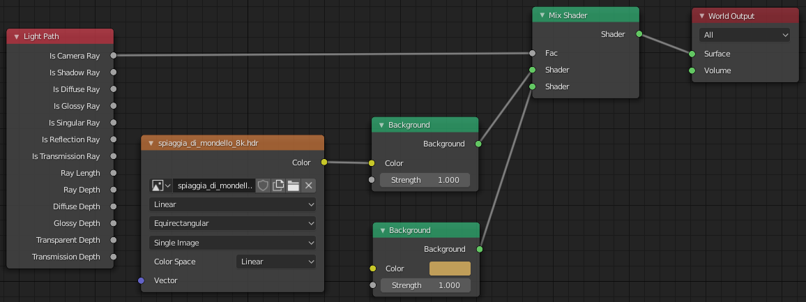

Make sure “use nodes” is selected, unticking turns off the node-based shader. Turning off the node can be useful during development. The Mix node is used to mix two shaders together.

**Aside:** The Light Path node is used to find out for which kind of incoming ray the shader is executing. The mix shader sets the relative mix of the upper input with the lower input. When FAC is 1 then the output will be 100% second (or lower position) input and 0% the first (top position). Is Camera Ray returns 1 when the rays first bounce is from the object (or in this case the world/background). The following (which you do not need to implement) shows “Is Camera Ray” is true when rays hit the background/world and so are blue.

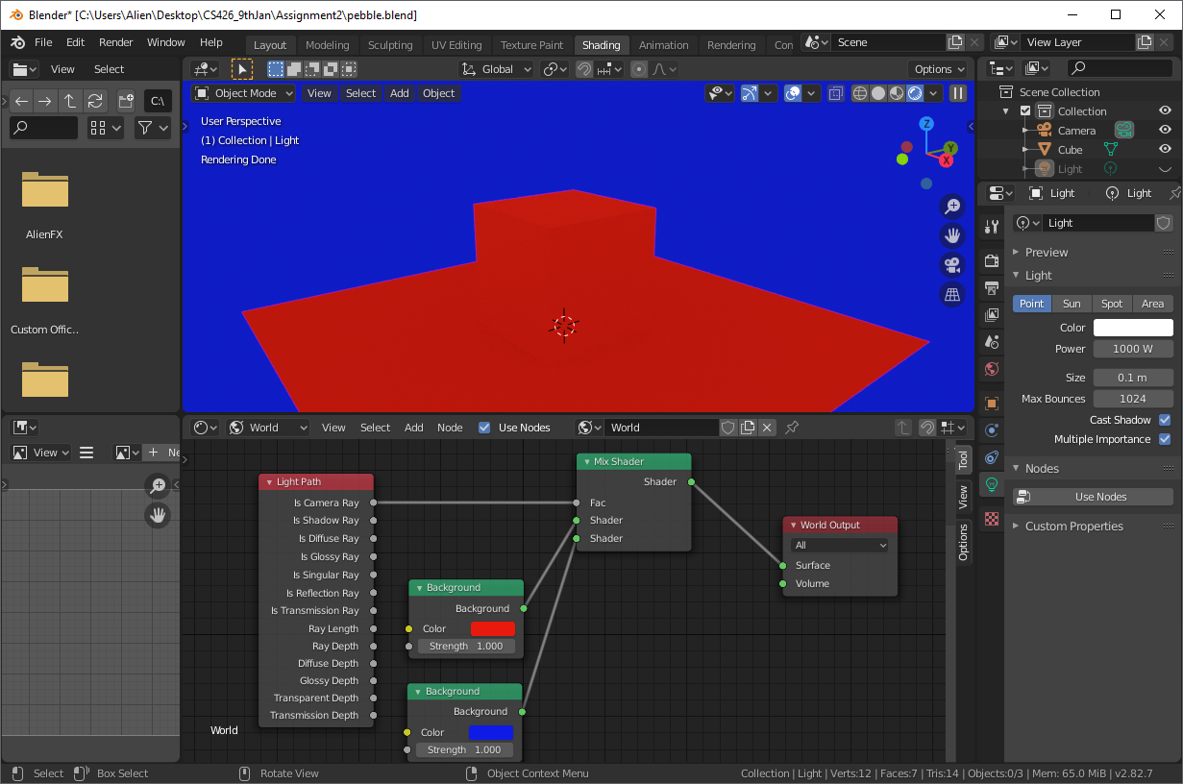

End of the aside.

Return to the Layout window and render the final scene.

Object mode – View – Align Camera – AlignActive Camera to view – press  to toggle between camera/redder view ad current edit view.

Submit a screen shot of the Layout window on your desktop which includes the rendered image in the scene.

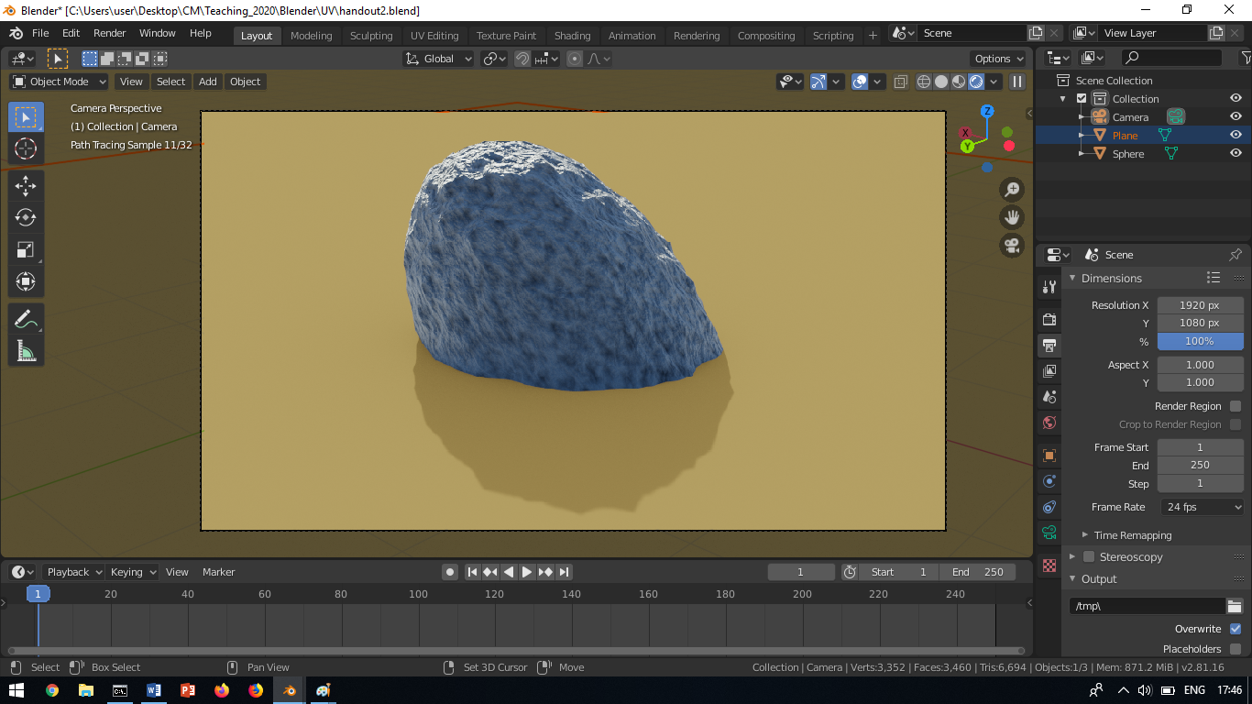

**Task 2** Create a realistic image of a pebble on a beach, submit an image of the workspace screen used to create the pebble which includes the final image of the rendered pebble (or separate images if you prefer). The HDRI image should only be used for lighting in the final rendered image and so should not be visible [3 marks].

**Task 3:** Recreate this scene of a sphere controlled by the shader shown. Add your own twist to the idea and submit a screen shot showing the shader you used and the resulting image. Comment on what is happening if it is different to the idea suggested [4 marks].

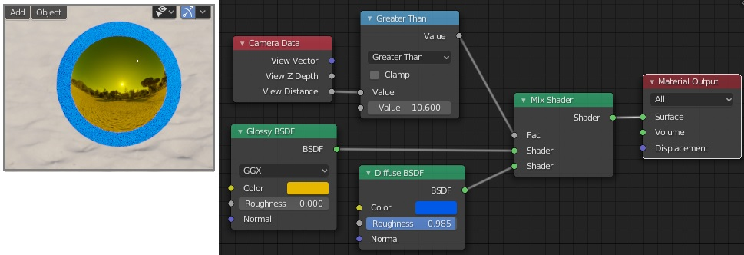

CM Feb2021 V2.1